# Assignment 1

## By : Ayush Nawal (17116020)

1. On applying voltage V1 in 0-5 V & V2 as 0.1 with frequency= 10000 hz

We get beta approximately between 95 & 100

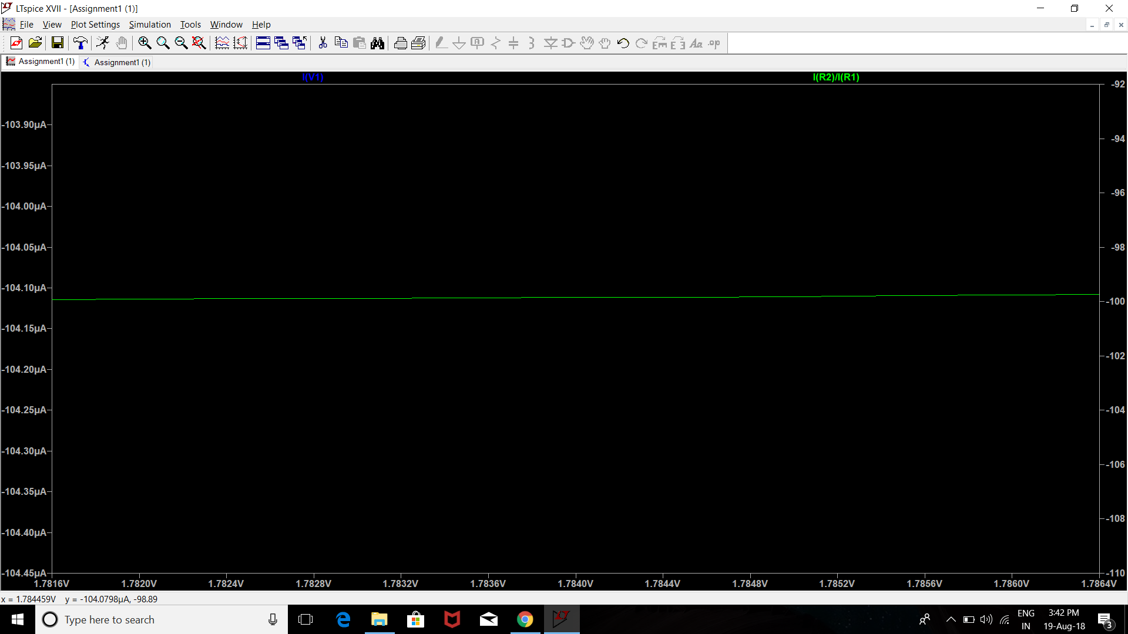

2

2.on applying same dc seep of 0-5V , we get maximum slope of v output between 1.6926 & 1.7697,we get V1 = average of both values = 1.7325 & V2 = difference by 2 = 0.03855 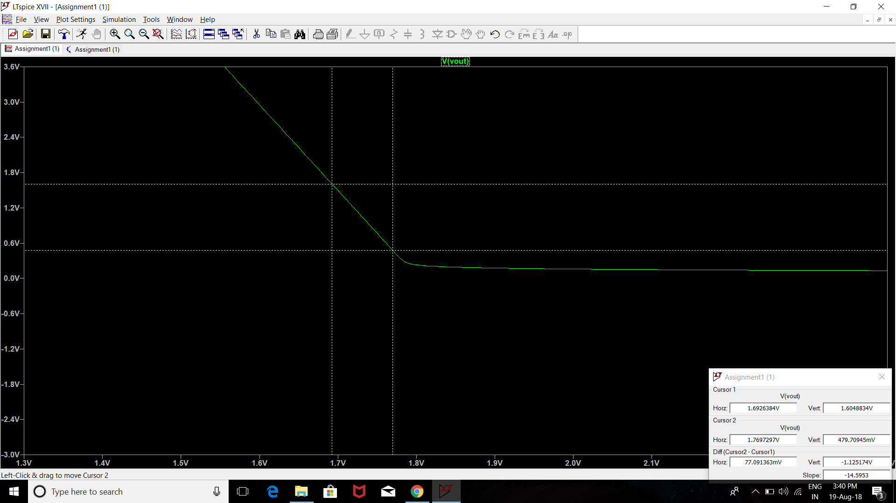

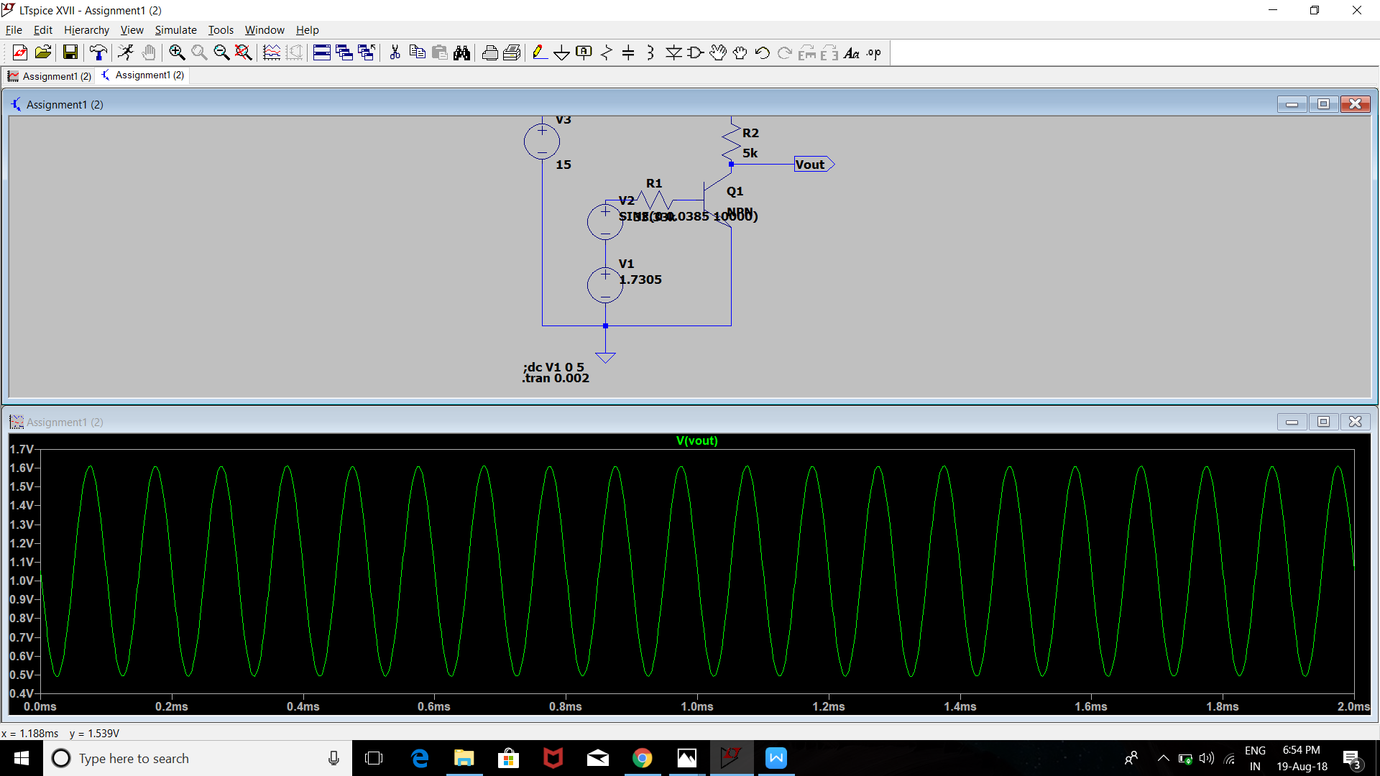

Respected waveform obtained for the corresponding v1 & v2.

3.on doubling v2 , we get v2 = 0.077 & v1 = 1.7305 so the respected waveform obtained is :

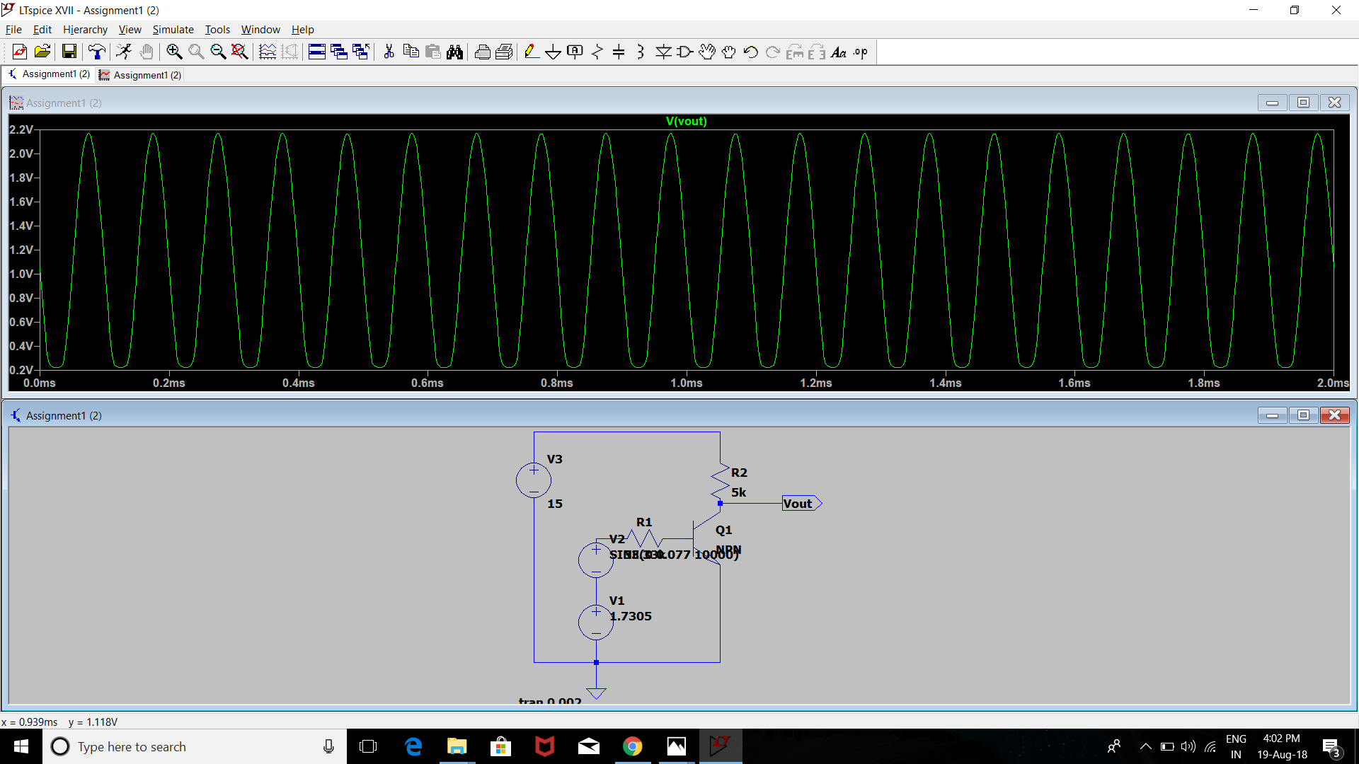

1. On doubling v1 , we get v1 = 3.461 & v2 = 0.0038 , this waveform is obtained :

